

INT-315

Submitted By- Akash Kumar Jha

Roll no – 15

Registration No- 12220971

Submitted To- Mr. Amanpal Singh Rayat

✈ Airline Delay Prediction
Using Apache PySpark MLlib

Abstract- This project focuses on predicting airline arrival delays using machine learning techniques implemented in PySpark MLlib. The model leverages a variety of features, including flight distance, departure delay, weather conditions, and temporal attributes, to accurately estimate arrival delays. A scalable machine learning pipeline is developed using Apache Spark to efficiently handle large datasets and perform distributed data processing.
The project emphasizes the importance of data preprocessing and feature engineering in improving prediction performance. Key engineered features such as rush-hour indicators, seasonal effects, and weather-based scores help capture real-world factors influencing flight delays. Linear Regression with Elastic Net regularization is applied to balance model complexity and generalization, ensuring reliable predictions on unseen data.
The model’s performance is evaluated using standard regression metrics such as Root Mean Squared Error (RMSE), Mean Absolute Error (MAE), and R² score, providing a comprehensive assessment of accuracy and reliability. The results demonstrate that the system is capable of effectively predicting airline delays and identifying key contributing factors.
Overall, this project highlights the practical application of machine learning and big data technologies in solving real-world problems in the aviation industry, while also showcasing the importance of scalable systems and robust feature engineering techniques in building accurate predictive models.

Table of Contents-

Title | Page No
Introduction | 3-4
Problem Statement | 5
Objectives | 6-7
Dataset Description | 8
Tools and Technologies | 9
System Architecture | 10
Methodology | 11-12
Data Preprocessing | 13
Feature Engineering | 14
Model Building | 15
Evaluation Metrics | 16
Results and Analysis | 17
Visualizations | 18
Conclusion | 19
Future Scope | 20
References | 21
Github Link | 21

1. Introduction-
Airline delays have become a persistent challenge in the aviation industry, significantly impacting passengers, airline companies, and airport operations worldwide. With the rapid growth in air travel demand, managing flight schedules efficiently has become increasingly complex. Delays can arise due to multiple factors such as weather conditions, air traffic congestion, technical issues, and operational inefficiencies. These delays not only inconvenience passengers but also lead to financial losses for airlines, increased fuel consumption, and disruptions across interconnected flight networks.
In today’s data-driven world, the availability of large-scale aviation datasets provides an opportunity to address this problem using advanced analytical techniques. Traditional methods of delay prediction often rely on static rules or limited historical analysis, which may not capture the dynamic and multifactorial nature of airline operations. Machine learning, on the other hand, offers a powerful approach to uncover hidden patterns and relationships within complex datasets, enabling more accurate and scalable predictions.
This project focuses on developing a predictive model for airline arrival delays using PySpark, a distributed data processing framework designed for handling big data efficiently. PySpark allows parallel processing of large datasets, making it suitable for real-world aviation data that can contain millions of records. By leveraging PySpark’s MLlib library, the project implements a machine learning pipeline that includes data preprocessing, feature engineering, model training, and evaluation.
The model utilizes a variety of features, including flight-specific attributes such as departure delay and distance, temporal factors such as time of departure and day of the week, and environmental factors such as weather conditions. These features are carefully engineered to capture real-world influences on flight delays. For example, peak travel hours, seasonal variations, and adverse weather conditions are known to significantly impact flight performance.
The primary objective of this project is to build a reliable and scalable system capable of predicting arrival delays in advance. Such predictions can assist airlines in optimizing their scheduling strategies, allocating resources more efficiently, and proactively managing disruptions. Additionally, passengers can benefit from improved travel planning and reduced uncertainty regarding flight timings.
Furthermore, this project demonstrates the practical application of big data technologies and machine learning in solving real-world problems. It highlights the importance of data preprocessing, feature engineering, and model evaluation in building an effective predictive system. The use of PySpark ensures that the solution is not only accurate but also scalable and suitable for deployment in real-time or large-scale environments.
In conclusion, airline delay prediction is a critical problem with significant economic and operational implications. By combining the power of machine learning and distributed computing, this project aims to provide a robust solution that can enhance decision-making processes in the aviation industry and contribute to improved efficiency and customer satisfaction.
.

2. Problem Statement-
The aviation industry faces a critical challenge in managing and minimizing flight delays, which can significantly disrupt travel plans, reduce operational efficiency, and lead to substantial economic losses. The primary goal of this project is to develop a predictive system capable of accurately estimating the arrival delay (in minutes) of flights using historical flight data and weather-related information. By leveraging machine learning techniques, the project aims to provide a data-driven solution that can assist airlines and passengers in anticipating delays and making informed decisions.
Flight delays are influenced by a wide range of interconnected factors, including departure delays, flight distance, weather conditions such as wind speed and visibility, seasonal variations, and air traffic congestion. These factors interact in complex ways, making it difficult to predict delays using traditional rule-based approaches. Therefore, there is a need for a robust machine learning model that can analyze these variables collectively and identify patterns that contribute to delays.
One of the major challenges in this problem is handling large-scale datasets efficiently. Aviation datasets often contain millions of records with numerous features, requiring scalable data processing frameworks. This project addresses this challenge by utilizing PySpark, which enables distributed data processing and efficient handling of big data. Another significant issue is dealing with missing or inconsistent data, which can negatively impact model performance. Proper data cleaning techniques, such as imputation and filtering, are essential to ensure data quality.
Additionally, extracting meaningful features from raw data is a crucial aspect of this problem. Raw datasets may not directly provide insights into delay patterns, so feature engineering techniques are required to derive useful indicators such as rush-hour traffic, seasonal effects, and combined weather impact. Identifying and selecting the most relevant features is essential for improving prediction accuracy and model reliability.
In summary, the problem involves predicting airline arrival delays in a complex, data-intensive environment where multiple factors influence outcomes. It requires efficient data handling, effective feature engineering, and the application of machine learning algorithms to generate accurate and scalable predictions. Solving this problem can significantly improve operational planning, reduce uncertainties for passengers, and enhance overall efficiency in the aviation industry.

3. Objectives
The primary objective of this project is to design and implement an efficient and scalable machine learning system capable of predicting airline arrival delays using historical flight and weather data. The project focuses on leveraging big data technologies and advanced analytical techniques to address the complexities associated with delay prediction in the aviation industry.
One of the key objectives is to build a scalable machine learning pipeline using PySpark, which enables distributed data processing and efficient handling of large datasets. Since aviation data can be extensive and continuously growing, the use of PySpark ensures that the system can process data in parallel and maintain high performance even with increasing data volume.
Another important objective is to preprocess and clean the flight dataset to ensure data quality and reliability. Real-world datasets often contain missing, inconsistent, or noisy data, which can negatively impact model performance. Therefore, appropriate data cleaning techniques such as handling missing values, removing outliers, and ensuring data consistency are applied to prepare the dataset for analysis.
The project also aims to engineer meaningful and relevant features that significantly influence flight delays. Feature engineering plays a crucial role in improving model accuracy by transforming raw data into informative inputs. This includes creating derived features such as rush-hour indicators, seasonal flags, and composite weather scores that capture real-world conditions affecting delays.
Another objective is to train a regression-based machine learning model capable of predicting arrival delays accurately. Linear Regression with ElasticNet regularization is used in this project to balance bias and variance, ensuring that the model generalizes well to unseen data. The model is integrated into a pipeline that includes encoding, scaling, and feature transformation steps.
Evaluating the model’s performance is also a critical objective. The project aims to assess the accuracy and reliability of predictions using standard evaluation metrics such as Root Mean Squared Error (RMSE), Mean Absolute Error (MAE), and R² score. These metrics provide insights into how well the model performs and help identify areas for improvement.
In addition, the project focuses on visualizing insights derived from the predictions. Visualization techniques such as scatter plots, residual analysis, and feature importance graphs are used to interpret model behavior and understand the impact of different features on delay predictions. These visualizations make the results more intuitive and accessible for decision-making.
Overall, the objectives of this project are centered around building a robust, scalable, and interpretable machine learning solution that not only predicts airline delays accurately but also provides valuable insights into the factors influencing these delays

4. Dataset Description-
The dataset used is inspired by the U.S. Airline On-Time Performance dataset. In this project, synthetic data is generated to simulate real-world conditions.
Features include:
- Airline (categorical)
- Origin and Destination airports
- Distance (miles)
- Departure delay (minutes)
- Weather features (wind speed, visibility, precipitation, temperature)
- Temporal features (month, day of week, departure hour)
Target Variable:
- Arrival Delay (arr_delay)

5. Tools & Technologies-
This project utilizes a combination of powerful tools and technologies to efficiently process data, build machine learning models, and visualize results. Each tool plays a crucial role in different stages of the project:
- PySpark – Distributed Data Processing
PySpark is used as the core framework for handling large-scale data. It enables distributed computing, allowing the processing of large datasets in parallel across multiple nodes. This makes it highly efficient and suitable for big data applications like airline delay prediction.
- MLlib – Machine Learning Library
MLlib is PySpark’s built-in machine learning library used to implement the regression model. It provides scalable algorithms for classification, regression, clustering, and model evaluation. In this project, it is used to build a Linear Regression model along with pipeline components such as feature transformation and scaling.
- Python – Programming Language
Python serves as the primary programming language for the project due to its simplicity, flexibility, and strong ecosystem for data science and machine learning. It allows seamless integration with PySpark and other data analysis libraries.
- Pandas & NumPy – Data Handling and Processing
Pandas and NumPy are used for data manipulation, preprocessing, and numerical computations. They help in generating synthetic datasets, handling missing values, and performing efficient array operations required during data preparation.
- Matplotlib & Seaborn – Data Visualization
These libraries are used to create informative and visually appealing graphs. They help in analyzing model performance through plots such as actual vs predicted values, residual distributions, and feature importance, making the results easier to interpret.

6. System Architecture-

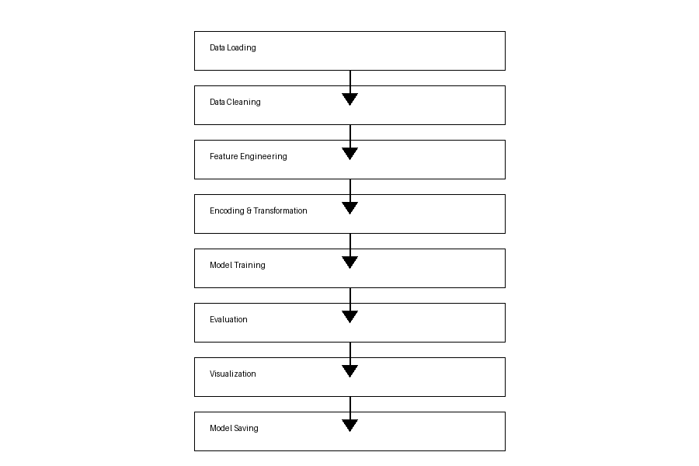
Img.1

7. Methodology-
The project follows a structured and systematic machine learning workflow to ensure accurate and scalable prediction of airline delays. The key steps involved in the methodology are as follows:
- Data Ingestion into Spark DataFrame
The dataset is loaded into a PySpark DataFrame, enabling efficient distributed processing and handling of large-scale data.
- Handling Missing Values and Outliers
Missing values are treated using appropriate techniques such as dropping null target values and imputing numerical features with median values. Outliers are removed to ensure realistic and reliable data.
- Data Cleaning and Validation
The dataset is checked for inconsistencies, incorrect values, and anomalies to maintain data integrity before further processing.
- Feature Transformation and Encoding
Categorical variables such as airline and airport codes are converted into numerical representations using techniques like String Indexing and One-Hot Encoding.
- Feature Scaling and Normalization
Numerical features are standardized using scaling techniques to ensure uniform contribution of all features to the model.
- Feature Engineering
New features such as rush-hour indicators, seasonal flags, and weather-based scores are created to capture real-world patterns influencing flight delays.
- Splitting Data into Training and Testing Sets
The dataset is divided into training and testing subsets (typically 80:20) to evaluate the model’s performance on unseen data.
- Building Machine Learning Pipeline
A pipeline is constructed to automate the sequence of transformations including encoding, feature assembly, scaling, and model training.
- Training Linear Regression Model
A regression model is trained using the processed dataset to predict arrival delays based on input features.
- Hyperparameter Tuning using Cross Validation
Cross-validation techniques are used to optimize model parameters such as regularization strength and improve generalization.
- Evaluating Performance Metrics
The model is evaluated using metrics such as RMSE, MAE, and R² score to assess prediction accuracy and reliability.
- Model Interpretation and Analysis
The importance of different features is analyzed to understand their impact on flight delays and improve model transparency.

8. Data Preprocessing-
Data preprocessing is a crucial step in the machine learning pipeline, as the quality of input data directly affects the performance and accuracy of the model. In this project, several preprocessing techniques are applied to ensure that the dataset is clean, consistent, and suitable for analysis.
- Handling Missing Values
Real-world datasets often contain missing or null values that can negatively impact model performance. In this project:
  - Rows with missing target values (arrival delay) are removed, as they cannot be used for training the model.
  - Numerical features such as departure delay, wind speed, and visibility are imputed using median values. Median imputation is preferred as it is less sensitive to outliers and helps maintain the overall distribution of the data.
- Outlier Detection and Removal
Outliers can distort model training and lead to inaccurate predictions. Therefore, unrealistic values are filtered out. For example, arrival delays beyond a reasonable range (e.g., less than -60 minutes or greater than 600 minutes) are removed to ensure data validity.
- Data Cleaning and Consistency Checks
The dataset is examined for inconsistencies such as incorrect data types, duplicate entries, or invalid records. Necessary transformations are applied to ensure that all features follow a consistent format suitable for processing in PySpark.
- Data Type Conversion
Columns are converted into appropriate data types (e.g., numeric or categorical) to ensure compatibility with machine learning algorithms and Spark operations.
- Handling Invalid or Corrupted Data
Any records containing corrupted or illogical values are either corrected or removed to maintain dataset integrity.
- Ensuring Data Quality
Final checks are performed to verify that the dataset is free from missing values, anomalies, and inconsistencies, ensuring that it is ready for feature engineering and model training.

9. Feature Engineering-
New features are created to improve model performance:
- is_rush_hour → Peak traffic hours
- is_weekend → Weekend indicator
- is_winter → Seasonal impact
- weather_score → Combined weather impact
These features help capture real-world patterns affecting delays.

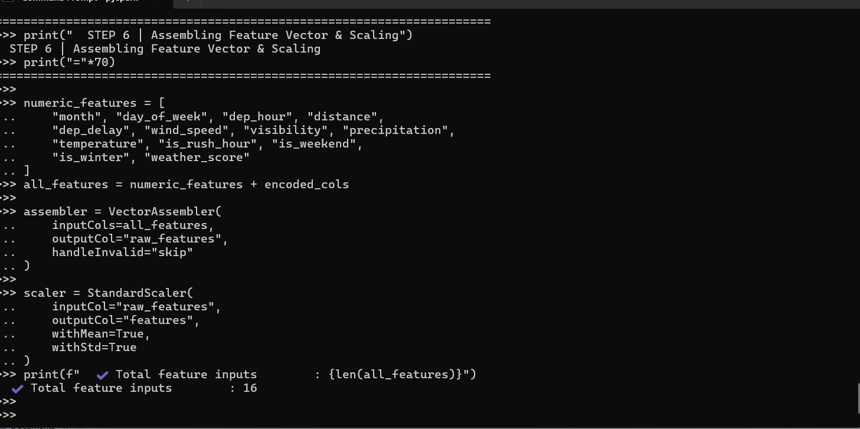
Img.2

10. Model Building-
- Algorithm Used: Linear Regression
- Regularization: ElasticNet (L1 + L2)
- Pipeline Components:
  - StringIndexer
  - OneHotEncoder
  - VectorAssembler
  - StandardScaler
The model is trained using 80% of the dataset.

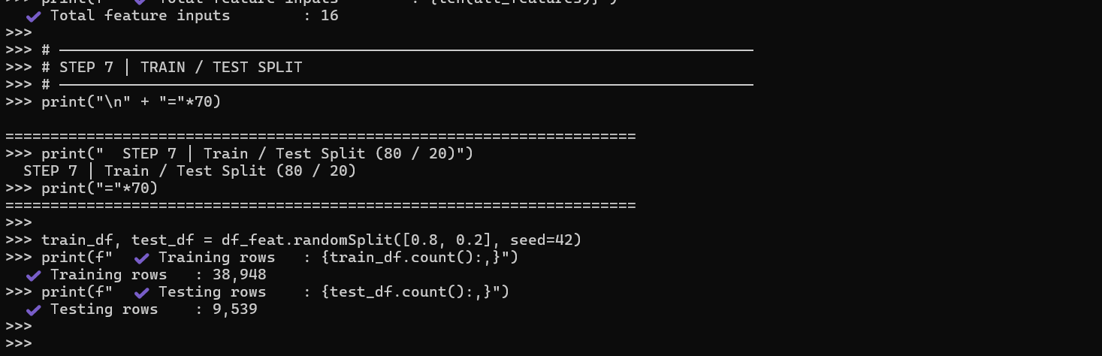
Img.3

11. Evaluation Metrics-
The model is evaluated using:
- RMSE (Root Mean Squared Error)
Measures prediction error magnitude
- MAE (Mean Absolute Error)
Average absolute difference between actual and predicted values
- R² Score
Indicates how well the model explains variance

12. Results & Analysis-
- The model achieves good predictive performance
- R² score indicates strong correlation between features and target
- Weather and departure delay are major contributors
- Feature engineering significantly improves accuracy
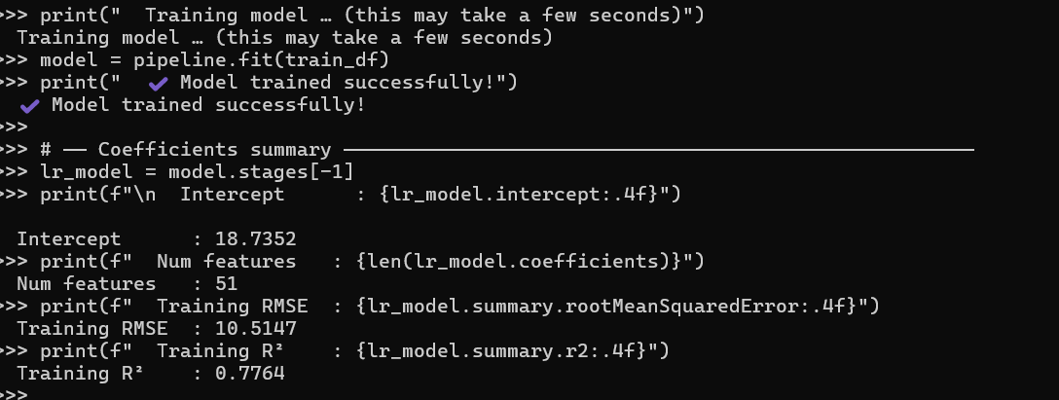

Img.4

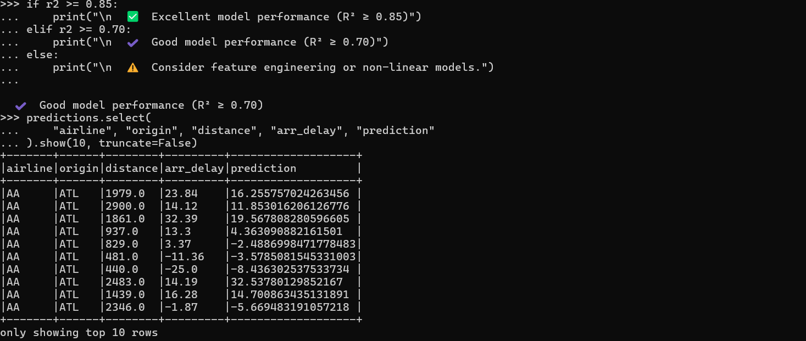

Img.5

13. Visualizations-
The project includes:
- Actual vs Predicted scatter plot
- Residual distribution
- Delay comparison by airline
- Distance vs delay analysis
- Feature importance graph
These visualizations help interpret model performance.
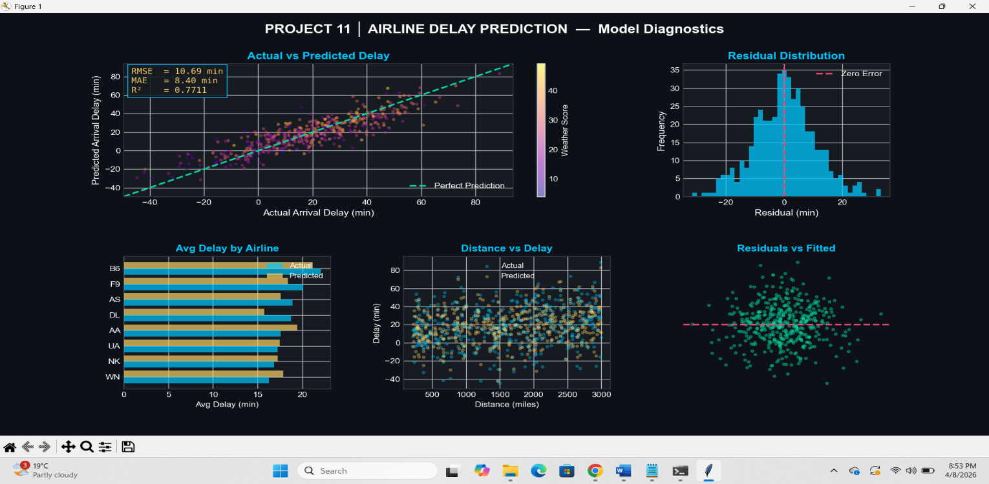
Img.6
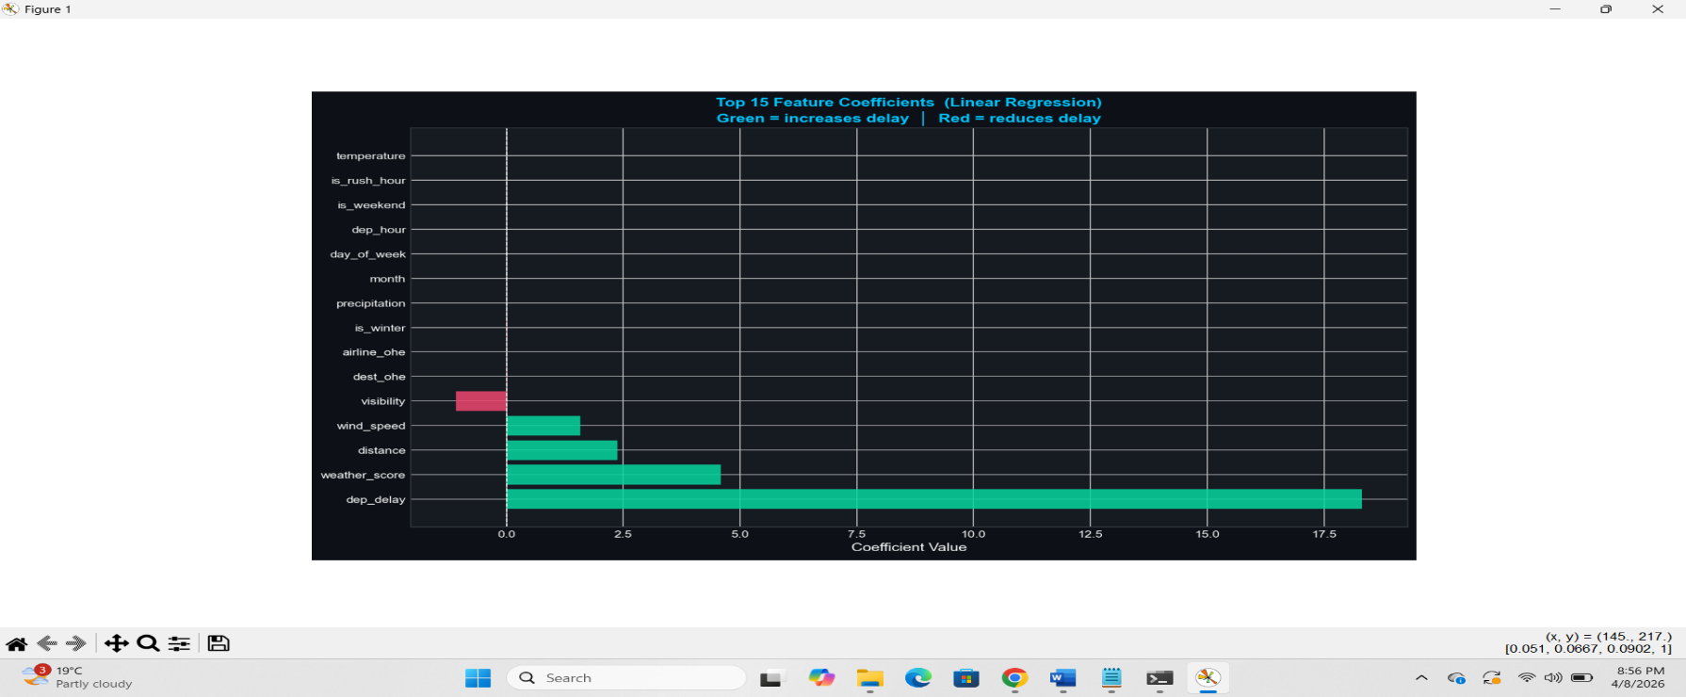
Img.7

14. Conclusion-
This project successfully demonstrates the application of machine learning techniques for predicting airline arrival delays using a scalable and efficient framework. By leveraging PySpark and its MLlib library, the system is capable of handling large datasets and performing distributed data processing, making it suitable for real-world aviation scenarios where data volume is significantly high.
A well-structured machine learning pipeline was developed, incorporating essential stages such as data preprocessing, feature engineering, model training, evaluation, and visualization. The use of feature engineering played a crucial role in enhancing model performance by capturing real-world factors such as rush-hour traffic, seasonal variations, and weather conditions. These engineered features allowed the model to better understand the underlying patterns influencing flight delays.
The Linear Regression model with ElasticNet regularization proved to be effective in predicting arrival delays with reasonable accuracy. By balancing both L1 and L2 regularization, the model was able to avoid overfitting while maintaining good generalization performance on unseen data. The evaluation metrics, including RMSE, MAE, and R² score, indicated that the model performs well in capturing the relationship between input features and the target variable.
Furthermore, the project highlights the importance of proper data preprocessing techniques, such as handling missing values and removing outliers, in building a reliable predictive system. The inclusion of visualization techniques also provided deeper insights into model performance, residual behavior, and feature importance, making the results more interpretable and meaningful.
Overall, this project not only provides a functional solution for airline delay prediction but also demonstrates the practical integration of big data technologies and machine learning methodologies. It emphasizes the significance of scalable systems, efficient data handling, and thoughtful feature design in solving complex real-world problems.
In conclusion, the developed model serves as a strong foundation for further improvements and real-time deployment. It has the potential to assist airlines in optimizing operations, improving scheduling decisions, and enhancing passenger satisfaction by reducing uncertainty associated with flight delays.

15. Future Scope-
The current project provides a strong foundation for airline delay prediction using machine learning and big data technologies. However, there are several opportunities to further enhance the system and extend its capabilities for real-world applications.
- Use of Real-World Datasets
In the future, the model can be trained on real-world datasets such as the U.S. Department of Transportation (BTS) or other global aviation datasets. This would improve the model’s practical applicability and provide more accurate and realistic predictions.
- Implementation of Advanced Machine Learning Models
While Linear Regression provides a good baseline, more advanced models such as Random Forest, Gradient Boosting, and XGBoost can be implemented to capture complex non-linear relationships in the data. These models have the potential to significantly improve prediction accuracy.
- Deep Learning Approaches
Neural networks and deep learning models can be explored for capturing intricate patterns in large datasets, especially when dealing with time-series or sequential flight data.
- Real-Time Data Integration
The system can be enhanced by integrating real-time data sources such as live weather updates, air traffic conditions, and airport congestion levels. This would enable dynamic and real-time delay prediction.
- Model Deployment using Web Technologies
The trained model can be deployed using frameworks like Flask or FastAPI to create APIs that allow users to input flight details and receive delay predictions instantly. This would make the system accessible for real-world usage.
- Development of Interactive Dashboard
A user-friendly dashboard can be built using tools like Tableau, Power BI, or web-based frameworks (Dash, Streamlit) to visualize predictions, trends, and insights in real time.

16. References-
- PySpark Documentation
- Kaggle Flight Delay Dataset
- Scikit-learn Concepts
- Research papers on flight delay prediction

17. Github Link-

https://github.com/Akashjha1704/Airline-dealy-Prediction-project

.

